George Smith

Lab 7

1. 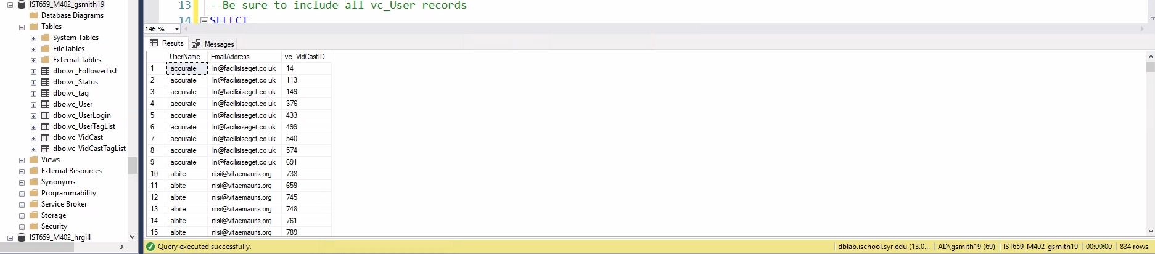
2. 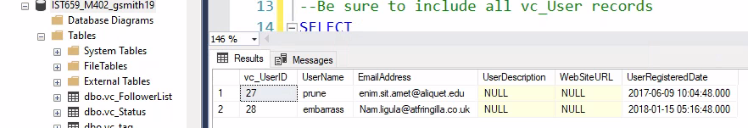

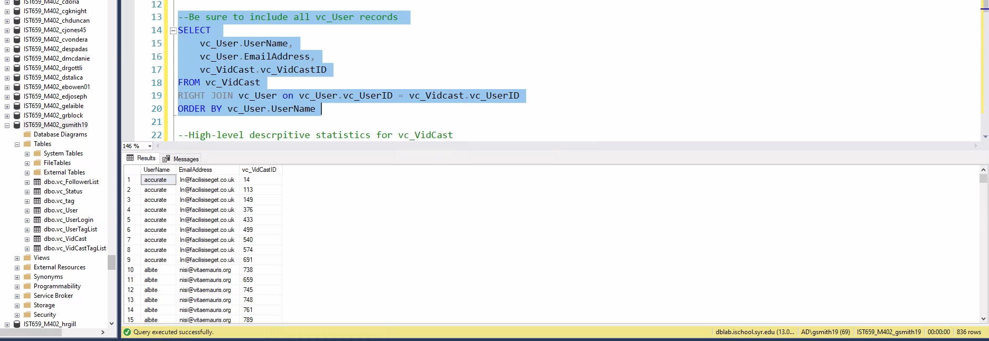



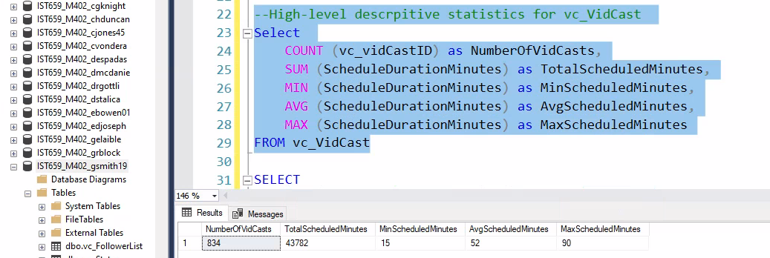

1. 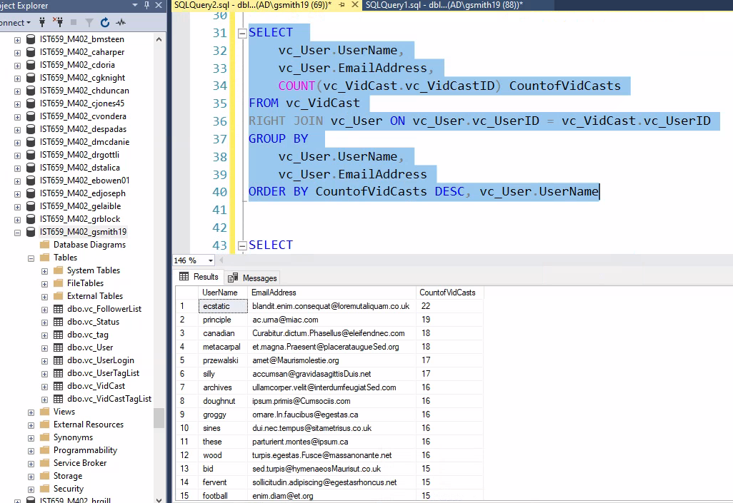
2. 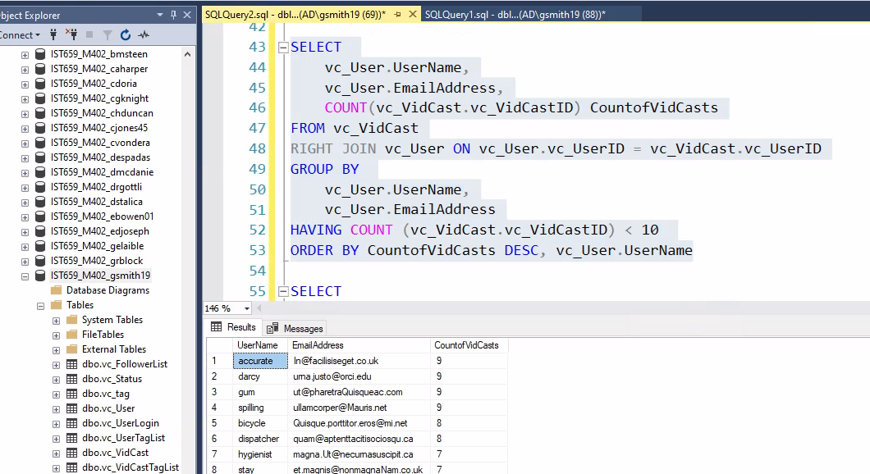
3. 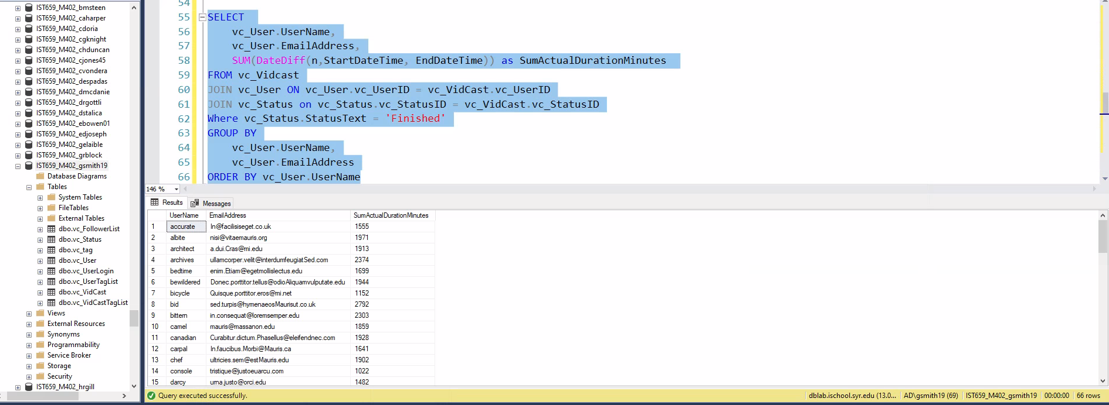
4. Part 2
5. 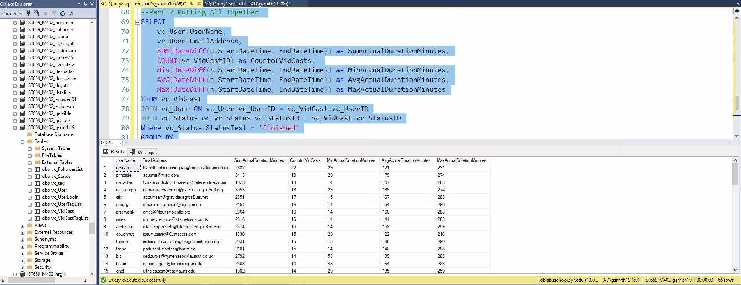

All Code:

SELECT

vc_User.UserName,

vc_User.EmailAddress,

vc_VidCast.vc_VidCastID

FROM vc_VidCast

JOIN vc_User ON vc_User.vc_UserID = vc_vidcast.vc_UserID

ORDER BY vc_User.UserName

--look for users who have notyet made any VidCasts

SELECT * FROM vc_User

WHERE vc_UserID NOT IN (SELECT vc_UserID FROM vc_VidCast)

--Be sure to include all vc_User records

SELECT

vc_User.UserName,

vc_User.EmailAddress,

vc_VidCast.vc_VidCastID

FROM vc_VidCast

RIGHT JOIN vc_User on vc_User.vc_UserID = vc_Vidcast.vc_UserID

ORDER BY vc_User.UserName

--High-level descrpitive statistics for vc_VidCast

Select

COUNT (vc_vidCastID) as NumberOfVidCasts,

SUM (ScheduleDurationMinutes) as TotalScheduledMinutes,

MIN (ScheduleDurationMinutes) as MinScheduledMinutes,

AVG (ScheduleDurationMinutes) as AvgScheduledMinutes,

MAX (ScheduleDurationMinutes) as MaxScheduledMinutes

FROM vc_VidCast

SELECT

vc_User.UserName,

vc_User.EmailAddress,

COUNT(vc_VidCast.vc_VidCastID) CountofVidCasts

FROM vc_VidCast

RIGHT JOIN vc_User ON vc_User.vc_UserID = vc_VidCast.vc_UserID

GROUP BY

vc_User.UserName,

vc_User.EmailAddress

ORDER BY CountofVidCasts DESC, vc_User.UserName

SELECT

vc_User.UserName,

vc_User.EmailAddress,

COUNT(vc_VidCast.vc_VidCastID) CountofVidCasts

FROM vc_VidCast

RIGHT JOIN vc_User ON vc_User.vc_UserID = vc_VidCast.vc_UserID

GROUP BY

vc_User.UserName,

vc_User.EmailAddress

HAVING COUNT (vc_VidCast.vc_VidCastID) < 10

ORDER BY CountofVidCasts DESC, vc_User.UserName

SELECT

vc_User.UserName,

vc_User.EmailAddress,

SUM(DateDiff(n,StartDateTime, EndDateTime)) as SumActualDurationMinutes

FROM vc_Vidcast

JOIN vc_User ON vc_User.vc_UserID = vc_VidCast.vc_UserID

JOIN vc_Status on vc_Status.vc_StatusID = vc_VidCast.vc_StatusID

Where vc_Status.StatusText = 'Finished'

GROUP BY

vc_User.UserName,

vc_User.EmailAddress

ORDER BY vc_User.UserName

--Part 2 Putting All Together

SELECT

vc_User.UserName,

vc_User.EmailAddress,

SUM(DateDiff(n,StartDateTime, EndDateTime)) as SumActualDurationMinutes,

COUNT(vc_VidCastID) as CountofVidCasts,

Min(DateDiff(n,StartDateTime, EndDateTime)) as MinActualDurationMinutes,

AVG(DateDiff(n,StartDateTime, EndDateTime)) as AvgActualDurationMinutes,

Max(DateDiff(n,StartDateTime, EndDateTime)) as MaxActualDurationMinutes

FROM vc_Vidcast

JOIN vc_User ON vc_User.vc_UserID = vc_VidCast.vc_UserID

JOIN vc_Status on vc_Status.vc_StatusID = vc_VidCast.vc_StatusID

Where vc_Status.StatusText = 'Finished'

GROUP BY

vc_User.UserName,

vc_User.EmailAddress

ORDER BY

CountofVidCasts Desc,

vc_User.UserName